LAPTOP REQUEST CATALOG ITEM

**ProblemStatement:**

Employees in the organization need a quick and efficient way to request laptops for work. The current process is manual and prone to delays, with no dynamic form behaviortoguideusersorensureaccuratedatacollection.Toaddressthis,aService Catalog item needs to be created, allowing users to easily request a laptop, with dynamic fields, clear instructions, and additional functionality like resetting the form if needed. The solution should also ensureall changes are tracked for governance and deployment.

# SettingUptheServiceNowInstance

### SignUpforaDeveloperAccount

* VisittheServiceNowDeveloperPortalat[https://developer.servicenow.com](https://developer.servicenow.com/).
* Createanewdeveloperaccountbyprovidingtherequiredinformation.

### RequestaPersonalDeveloperInstance

* Logintoyourdeveloper account.
* Navigatetothe“Manage>Instance” section.
* Click“RequestInstance”andchoosethelatestavailablerelease.

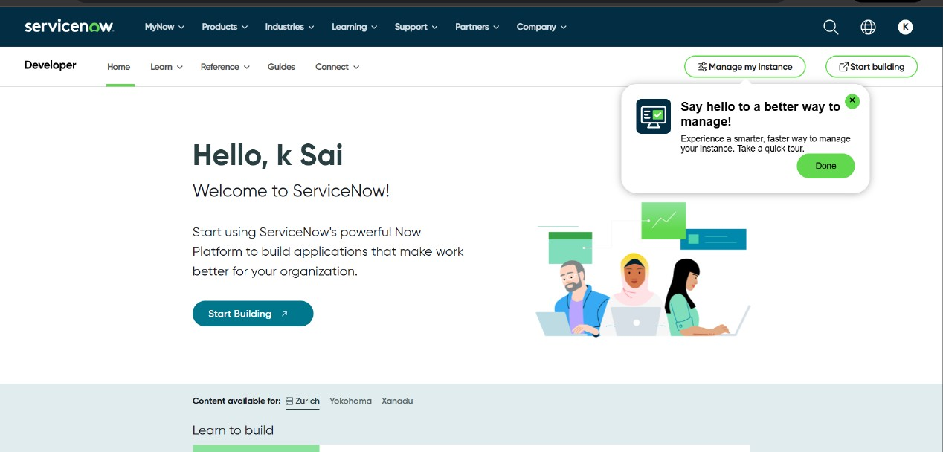

# CreateLocalUpdateSet

## Steps:

* 1. OpenServiceNowinstance.
  2. Navigateto:All→UpdateSets→LocalUpdateSets
  3. ClickonNew.
  4. Fillinthefollowingdetails:oName:Laptop Request
  5. Click Submit.
  6. ClickMakeCurrentonthecreatedupdateset.

Note:Performallactionsunderthis"LaptopRequest"updatesetonly.

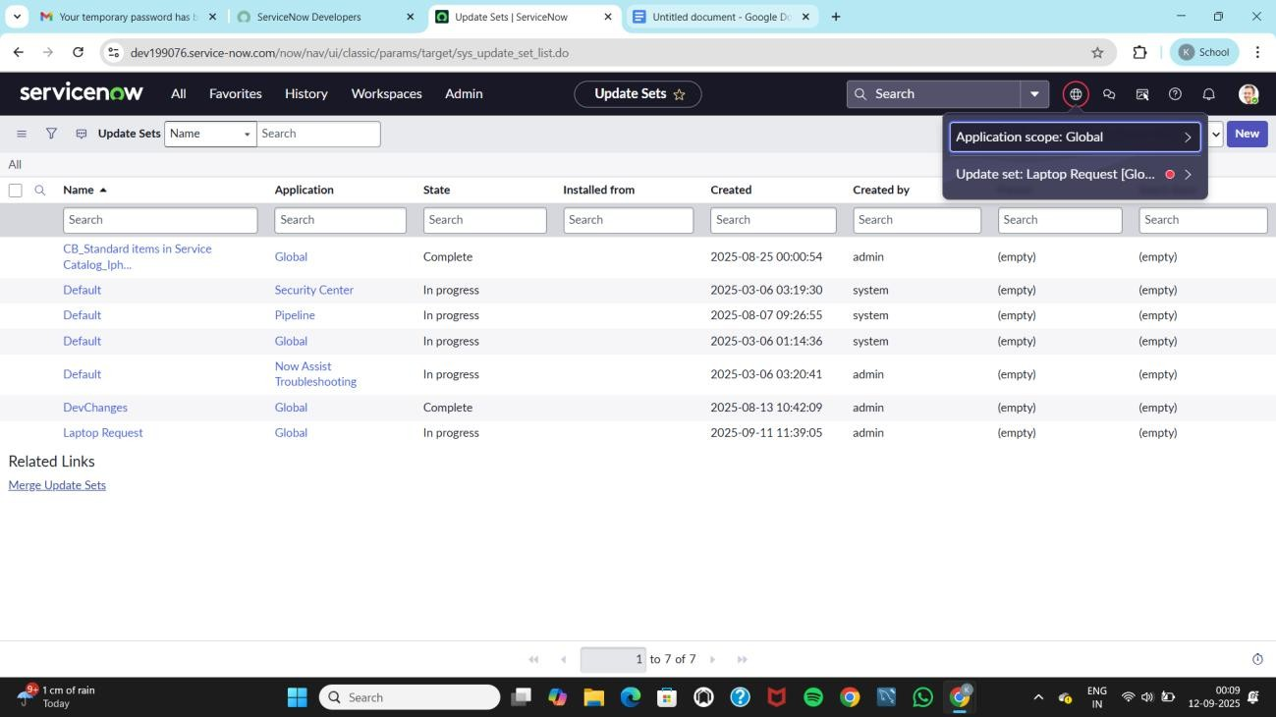

# CreateServiceCatalogItem

## Steps

* 1. Goto:All→ServiceCatalog→MaintainItems
  2. ClickonNew.
  3. Fillintheform:

Name: Laptop Request Catalog:ServiceCatalog Category: Hardware

ShortDescription:Usethisitemtorequestanewlaptop

* 1. ClickSave(notSubmit).

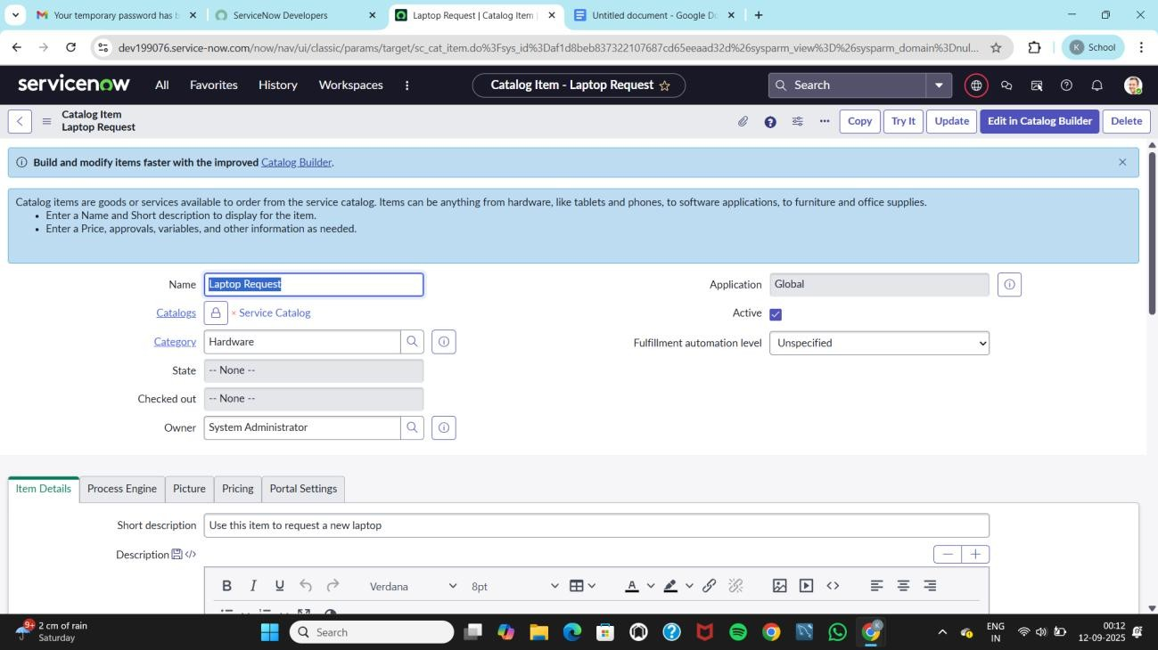

# AddVariables

## Step1:

* 1. AftersavingtheLaptopRequestcatalogitem,scrolldowntotheVariables related list (at the bottom of the form).
  2. ClickontheNewbuttontoaddavariable.
  3. Addthefirstvariablewiththefollowingdetails:
     + VariableName:LaptopModel
     + Type:SingleLineText
     + Name:laptop_model
     + Order:100
  4. 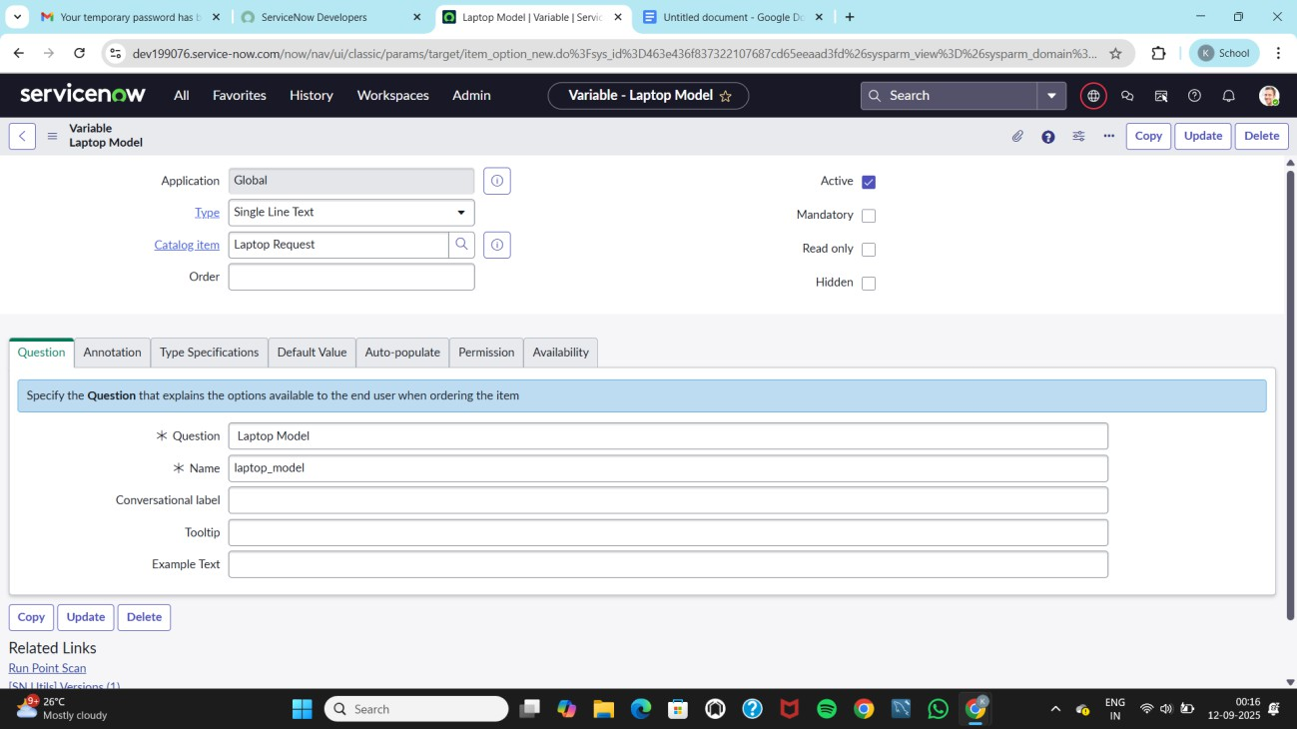Click Submit.

## Step2:

Repeatthesameprocesstoaddtheremainingvariablesonebyone:

### Variable2

* **VariableName**:Justification
* **Type**:MultiLineText
* **Name**: justification
* **Order**:200
* Click**Submit**.

### Variable3

* **VariableName**:AdditionalAccessories
* **Type**:Checkbox
* **Name**: additional_accessories
* **Order**:300
* Click**Submit**.

### Variable4

* **VariableName**:AccessoriesDetails
* **Type**:MultiLineText
* **Name**: accessories_details
* **Order**:400
* 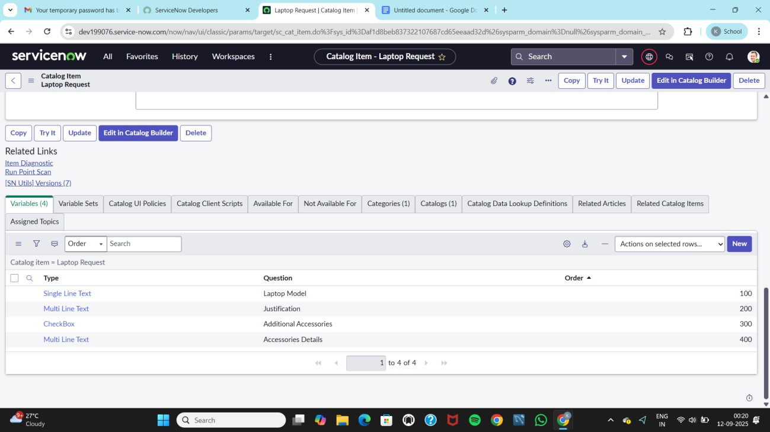Click**Submit**.

### Step 3:

Onceallvariablesareadded,clickSaveontheLaptopRequestcatalogitemformto save the item along with its variables.

# CreateCatalogUIPolicy

## Steps:

* 1. Navigateto:

### All→ServiceCatalog→MaintainItems

* 1. OpentheLaptopRequestcatalogitem.
  2. Scrolldownto**CatalogUIPolicies**(RelatedList).
  3. Clickon**New**.
  4. Filltheform:
* **ShortDescription**:ShowAccessories Details

### WhentoApply:

**Field**:additional_accessories

**Operator**: is

**Value**:true

* 1. 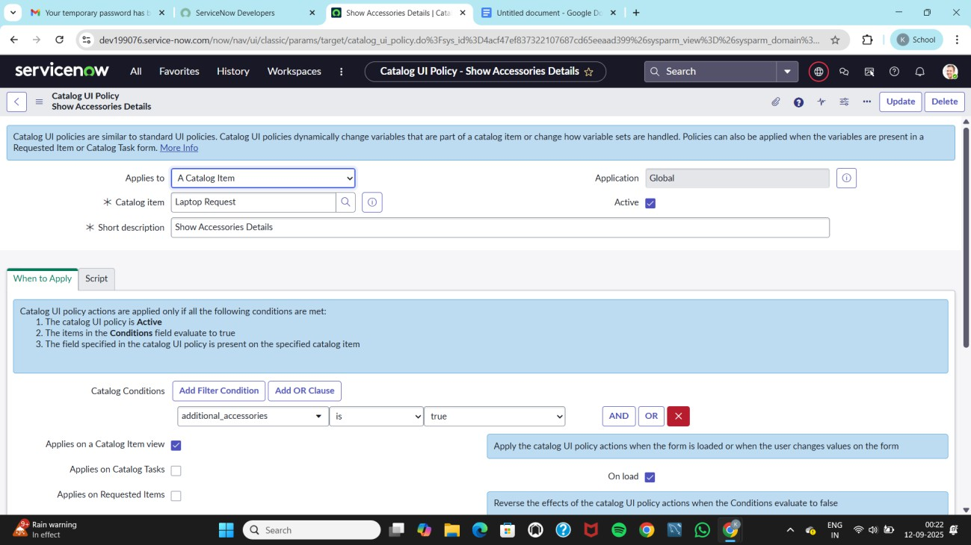Click**Save**(donotsubmityet).

# CreateCatalogUIPolicyAction

## Steps:

* 1. InthesameUIPolicyform,scrollto**CatalogUIPolicy Actions**.
  2. Click**New**.
  3. Fillinthe form:

**VariableName**:accessories_details **Order**: 100 o Mandatory: True **Visible**: True

* 1. Click**Save**.
  2. Thenclick**Save**againontheUIPolicyform.

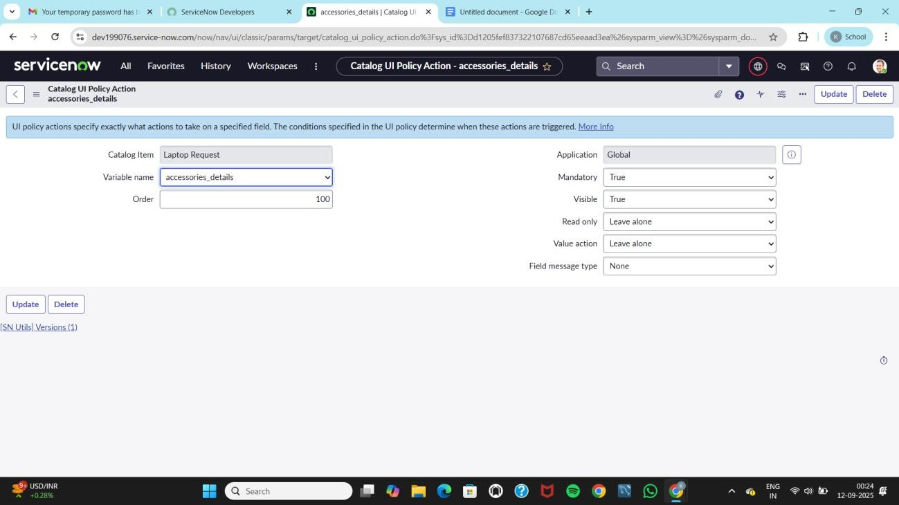

# CreateUIAction(ResetButton)

## Steps:

* 1. Navigateto:

### All→SystemDefinition→UIActions

* 1. Clickon**New**.
  2. Fillinthe following:
* **Table**:sc_cart(ShoppingCart)
* **Order**:100
* **Actionname**:Resetform
* **Client**:Checked

### Script:

functionresetForm(){

g_form.clearForm();//Clearsallfieldsintheform alert("The form has been reset.");

}

* 1. 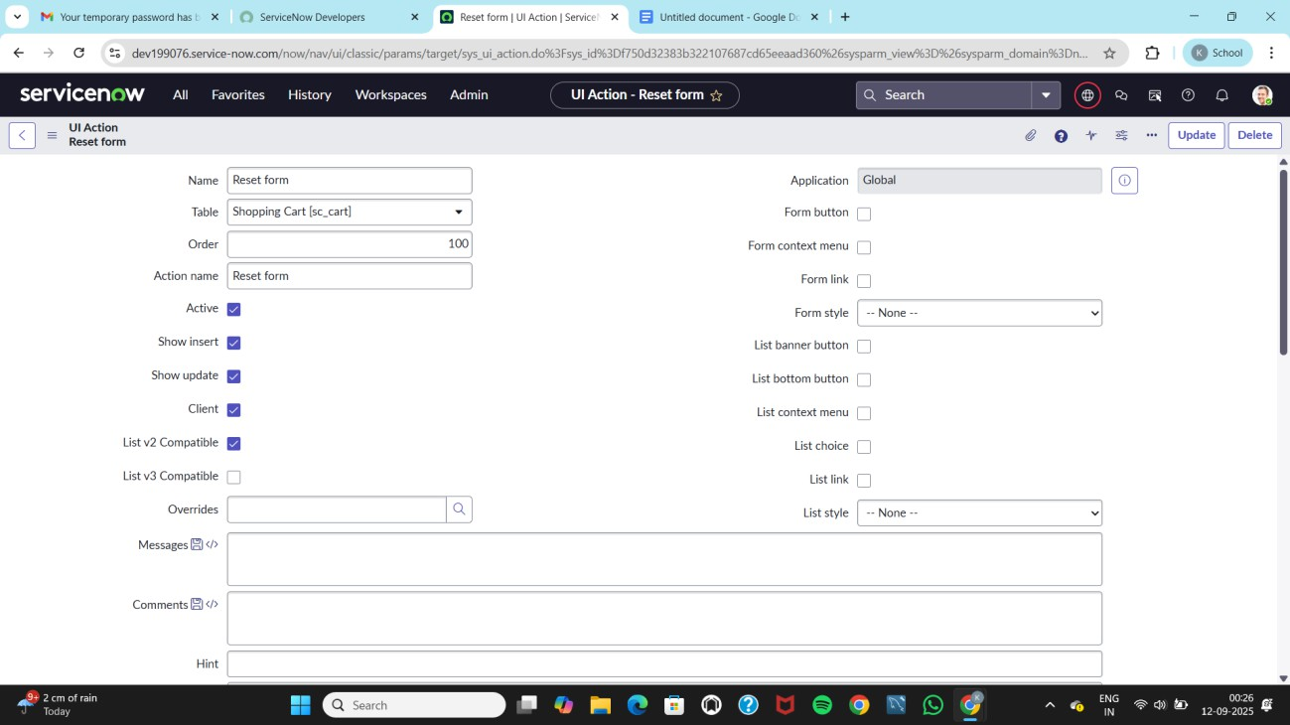Click**Save**.

# ExportUpdateSettoXML

## Steps:

* 1. Navigateto:

### All→UpdateSets→LocalUpdateSets

* 1. Opentheupdateset:Laptop Request.
  2. SetStateto:**Complete**.
  3. Inthe **Updates**relatedlisttab,reviewallupdates.
  4. Click**ExporttoXML**todownloadtheupdateset.

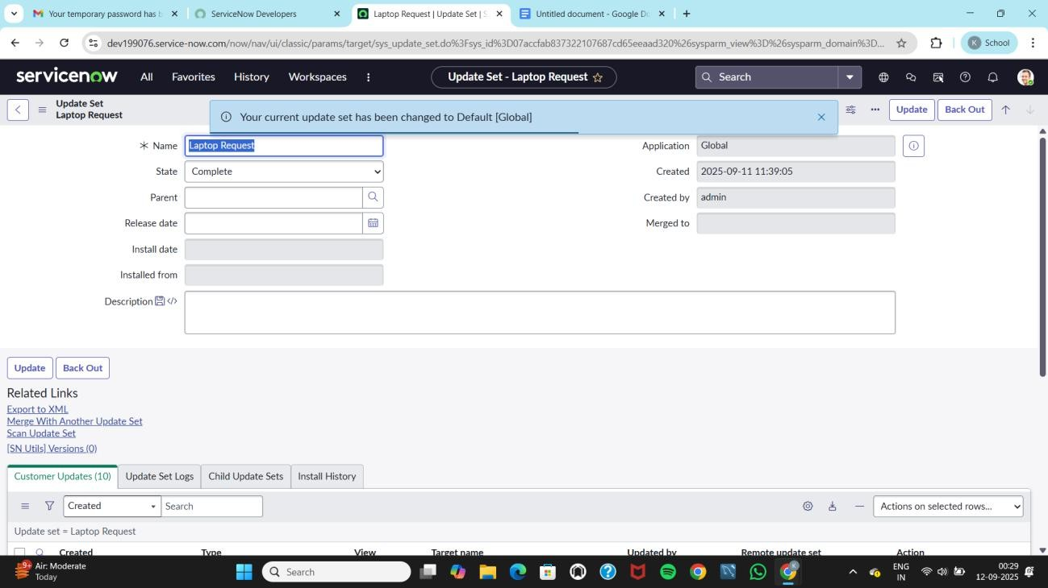

# RetrieveUpdateSetinAnotherInstance

### Steps:

* 1. OpenanotherServiceNowinstancein**IncognitoMode**.
  2. Loginwithvalid credentials.
  3. Navigateto:

### All→UpdateSets→RetrievedUpdate Sets

* 1. Click**ImportUpdateSetfromXML**.
  2. Uploadthepreviouslydownloaded.xmlfile.
  3. Click**Upload**.

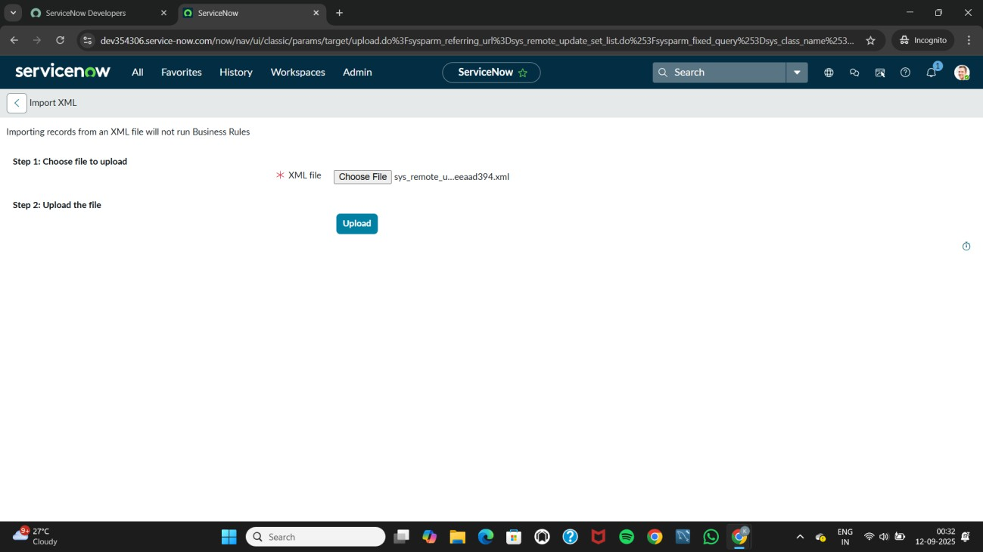

* 1. OpentheuploadedsetLaptopRequest Project.
  2. Click**PreviewUpdateSet**.
  3. Click**CommitUpdateSet**.
  4. Reviewallrelated**Updates**tab.

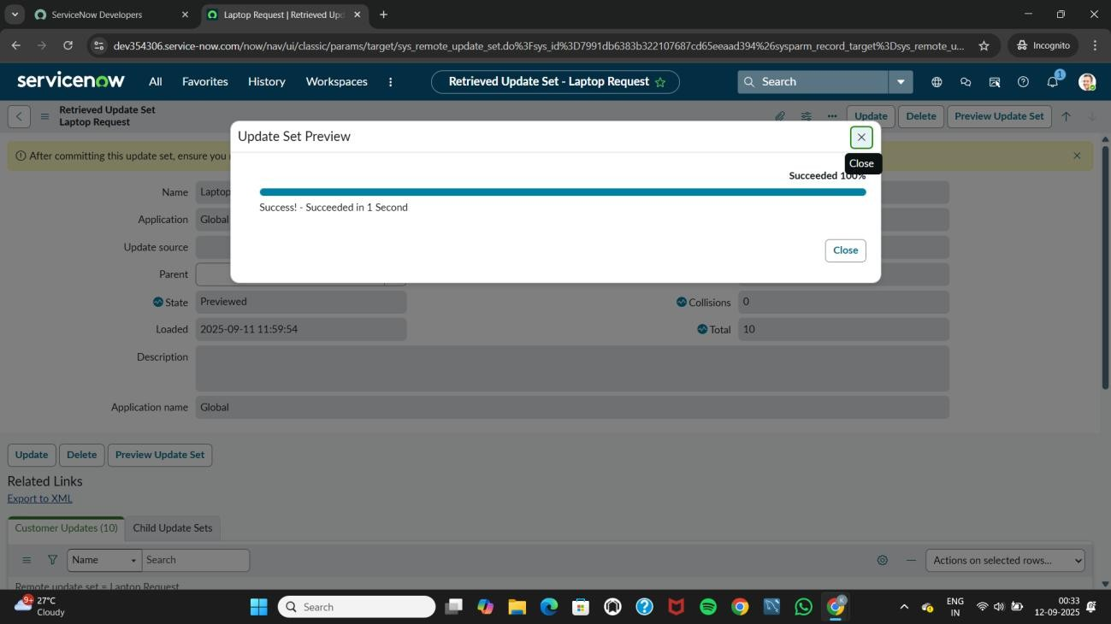

# TesttheCatalogItem

## Steps:

* 1. Inthe**TargetInstance**,navigateto:

### All→ServiceCatalog→Catalog

* 1. Open**Hardware**category.
  2. Searchandopentheitem:Laptop Request.

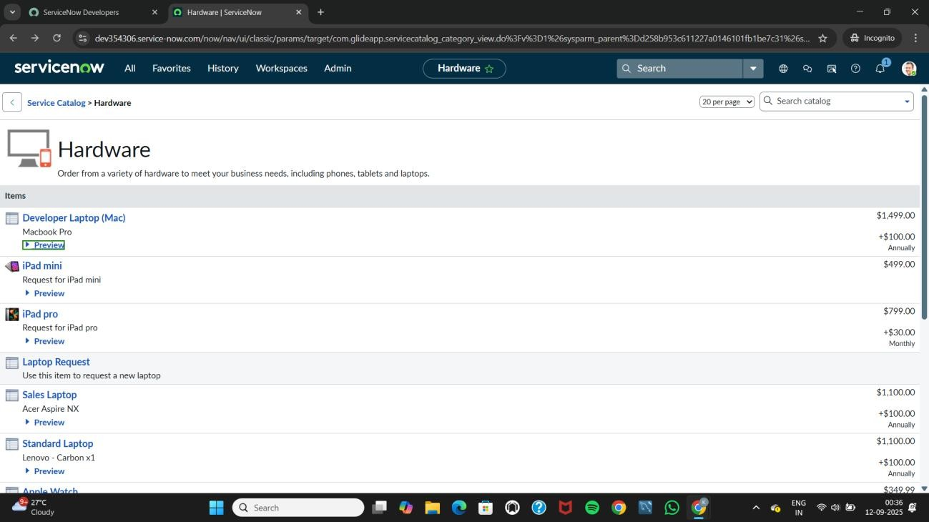

* 1. Observethedisplayedvariables:
* LaptopModeloJustification
* AdditionalAccessories
  1. ScenarioTest:
* **Check**thecheckbox:AdditionalAccessories
* ThefieldAccessoriesDetailsbecomes**visibleandmandatory**.

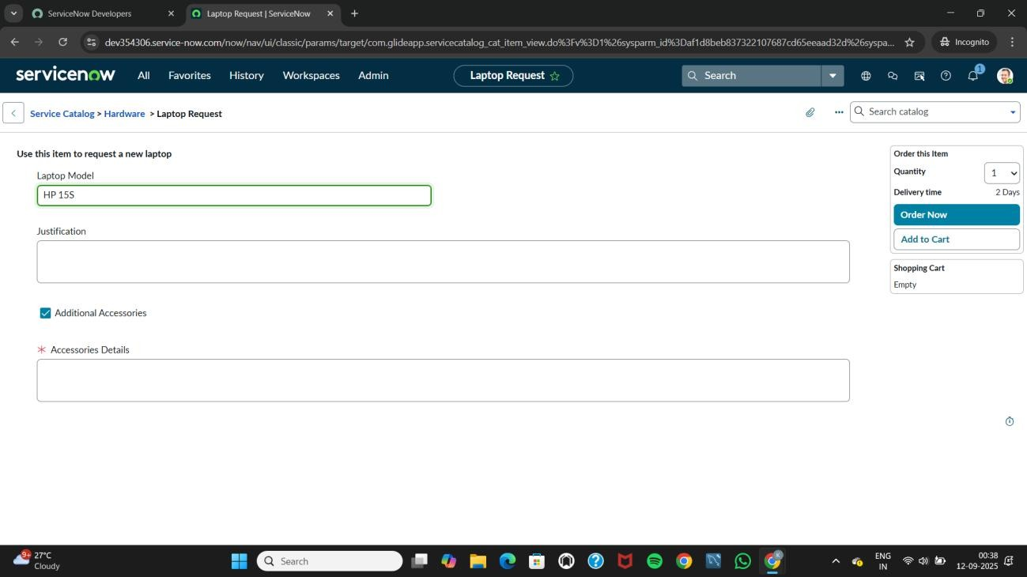

# Conclusion:

The Laptop Request Catalog Item project successfully streamlines the process of requesting laptops within the organization by leveraging ServiceNow's Service Catalog capabilities.Throughtheimplementationofadynamiccatalogitem,theprojectensures that users have an intuitive and user-friendly interface, reducing errors and improving efficiency.This project demonstrates how ServiceNow can be used to replace manual, error-prone processes with automated, efficient, and user-centric solutions. It not only improves service delivery but also enhances employee satisfaction by providing a modern and streamlined request experience.